A
Minor Project Report
on
Classification of credit holders using traditional machine learning algorithms
Submitted for partial fulfillment for the degree of

Bachelor of Technology

School of computing and IT

in
Department of Information Technology

by

Amitabh Sharma 169108020
Anjali Mohini 169108022

Under the Guidance of
Mrs. Shikha Mundra

(April-2019)

SCHOOL OF COMPUTING AND INFORMATION TECHNOLOGY

MANIPAL UNIVERSITY JAIPUR



CERTIFICATE

This is to certify that the project titled Classification of credit holders using machine learning algorithms is a record of the bonafide work done by AMITABH SHARMA (169108020), ANJALI MOHINI (169108022) submitted in partial fulfilment of the requirements for the award of the Degree of Bachelor of Technology (B.Tech) in (Discipline) of Manipal University Jaipur, during the academic year 2019-20.

Dept Guide Name

Mrs. Shikha Mundra
Dept. of computer Science

Manipal University Jaipur

HOD Name

Dr. Pankaj Vyas
Dept. Information technology

Manipal University Jaipur

ABSTRACT

Credit Score is a numerical expression which analyze the creditworthiness of any individual. Credit scoring becomes important as it help the bank workers to estimate whether the individual qualifies for a loan or not. The bank workers receive a large number of credit application on daily basis it is impossible to analyze this huge amount of data in terms of both economic as well as manpower so we apply various data mining techniques to check the creditability of the applicant.

The aim of this study is focused on techniques that are used to check the probability of the defaulter credit applicant as well as the method by which the accuracy could be increased. We have applied various machine learning classification algorithm along with artificial neural network and identified the best technique that could be used for credit scoring.

LIST OF TABLES

Table No | Table Title | Page No
1 | Logistic Regression precision recall and accuracy | 10
2 | Svm precision recall and accuracy | 10
3 | Random Forest precision recall and accuracy | 11
4 | Neural Network precision recall and accuracy | 12
5 | K nearest precision recall and accuracy | 12

LIST OF FIGURES

Figure No | Figure Title | Page No
1 | Logistic Regression Graphical View | 4
2 | Svm graphical view | 5
3 | Random Forest graphical view | 5
4 | Neural Network graphical view | 6
5 | K nearest neighbor | 6
6 | Data pre-processing block diagram | 9

 | Contents
 | Page No
Abstract | i
List Of Figures | ii
List Of Tables | iii

Chapter 1 INTRODUCTION

1.1 Introduction to work done/ Motivation (Overview, Applications & Advantages) 1

1.2 Project Statement / Objectives of the Project 1

Chapter 2 BACKGROUND OVERVIEW

2.1 Conceptual Overview (Concepts/ Theory used) 2

2.2 Technologies Involved 5

2.3 Libraries Used 7

Chapter 3 METHODOLOGY

3.1 Detailed methodology that will be adopted 9

3.2 Block diagrams

Chapter 4 IMPLEMENTATION AND RESULTS

4.1 Results 10

4.2 Prototype 11

Chapter 5 FUTURE WORK AND CONCLUSION

5.1 Progress Chart 13

5.2 Conclusion 14

REFERENCES 15

INTRODUCTION

1.1 INTRODUCTION TO WORK DONE

With this high pacing technological world, we are completely dependent upon online applications these days. The credit market has detonated over the years. In the past year’s credit flow crises has become, one of the most imperative issues, bank has over issued cash and credit irrespective of the ability of the client to repayments, and also their overconsumptions history. This situation setbacks consumer and finance company relationship badly. Growing demand for consumer credit has headed to the competition in credit industry.

Credit managers have to overtake this situation in the most efficient and hustle free way they can. So by developing and applying machine learning models they can manage and analyze credit data. Which will save time, minimize the reduction errors and maximize the process of credit scoring. Credit scoring is defined as a technique that helps lenders decide whether to grant credit to the customers on the basis of the different parameters regarding customer such as age, income and marital status, their past history with the banks, if the customer is allied with any bankruptcy cases or not. In current years, numerous quantitative approaches have been offered for credit risk evaluation or for filtering the defaulters from the big dataset of the finance companies. Among all existing methods, data mining methods have gained more popularity than the others because of their incomparable capability of determining practical knowledge from the database and changing them into beneficial information.

A lot of Statistical approaches, including discriminant analysis, logistic regression, Bayes classifier, and nearest neighbor, are applied to develop models for classifying the clients as a defaulter. With the high development in the field of artificial intelligence and machine learning, artificial neural networks and classification trees were also implemented for prediction of credit defaulter. By credit defaulter it means, there are situations where many clients are not able to return the money back to the company at the specified threshold time, so in that situation the finance company declares that client as credit defaulter, who is not eligible for getting credits in any form. The elementary motive of this study is helping the researchers to be aware of the present scenario, find the limitations in different approaches and suggest more efficient means.

1.2 PROJECT STATEMENT:

This project aimed at the case of customer’s default payments in Taiwan and compares the predictive accuracy of probability of default among six data mining methods. From the perspective of risk management, the result of predictive accuracy of the estimated probability of default will be more valuable than the binary result of classification - credible or not credible clients. Because the real probability of default is unknown, this study presented the novel Sorting Smoothing Method to estimate the real probability of default. With the real probability of default as the response variable (Y), and the predictive probability of default as the independent variable (X), the simple linear regression result (Y = A + BX) shows that the forecasting model produced by artificial neural network has the highest coefficient of determination; its regression intercept (A) is close to zero, and regression coefficient (B) to one. Therefore, among the six data mining techniques, artificial neural network is the only one that can accurately estimate the real probability of default.
(1)
BACKGROUND OVERVIEW

2.1 CONCEPTUAL OVERVIEW:

SUPERVISED AND UNSUPERVISED LEARNING
Data scientists use many different kinds of machine learning algorithms to discover patterns in big data that lead to actionable insights. At a high level, these different algorithms can be classified into two groups based on the way they “learn” about data to make predictions: supervised and unsupervised learning.
Supervised Machine Learning:

The majority of practical machine learning uses supervised learning. Supervised learning is where you have input variables (x) and an output variable (Y) and you use an algorithm to learn the mapping function from the input to the output Y = f(X). The goal is to approximate the mapping function so well that when you have new input data (x) that you can predict the output variables (Y) for that data.

Techniques of Supervised Machine Learning algorithms include linear and logistic regression, multi-class classification, Decision Trees and support vector machines. Supervised learning requires that the data used to train the algorithm is already labeled with correct answers. For example, a classification algorithm will learn to identify animals after being trained on a dataset of images that are properly labeled with the species of the animal and some identifying characteristics.

Supervised learning problems can be further grouped into Regression and Classification problems. Both problems have as goal the construction of a succinct model that can predict the value of the dependent attribute from the attribute variables. The difference between the two tasks is the fact that the dependent attribute from the attribute variables. The difference between the two tasks is the fact that the dependent attribute is numerical for regression and categorical for classification.

Unsupervised Machine Learning:

Unsupervised learning is a type of machine learning algorithm used to draw inferences from datasets consisting of input data without labeled responses.
The most common unsupervised learning method is cluster analysis, which is used for exploratory data analysis to find hidden patterns or grouping in data. The clusters are modeled using a measure of similarity which is defined upon metrics such as Euclidean or probabilistic distance. Common clustering algorithms include:
- Hierarchical clustering: builds a multilevel hierarchy of clusters by creating a cluster tree
- k-Means clustering: partitions data into k distinct clusters based on distance to the centroid of a cluster
- Gaussian mixture models: models clusters as a mixture of multivariate normal density components
- Self-organizing maps: uses neural networks that learn the topology and distribution of the data
- Hidden Markov models: uses observed data to recover the sequence of states

(2)
- Unsupervised learning methods are used in bioinformatics for sequence analysis and genetic clustering; in data mining for sequence and pattern mining; in medical imaging for image segmentation; and in computer vision for object recognition.

CLASSIFICATION AND REGRESSION

a). Classification:

A classification problem is when the output variable is a category, such as “red” or “blue” or “disease” and “no disease”. A classification model attempts to draw some conclusion from observed values. Given one or more inputs a classification model will try to predict the value of one or more outcomes.
For example, when filtering emails “spam” or “not spam”, when looking at transaction data, “fraudulent”, or “authorized”. In short Classification either predicts categorical class labels or classifies data (construct a model) based on the training set and the values (class labels) in classifying attributes and uses it in classifying new data. There are a number of classification models. Classification models include logistic regression, decision tree, random forest, gradient-boosted tree, multilayer perceptron, one-vs-rest, and Naive Bayes.

b). Regression:

A regression problem is when the output variable is a real or continuous value, such as “salary” or “weight”. Many different models can be used, the simplest is the linear regression. It tries to fit data with the best hyper-plane which goes through the points.

Classification Algorithms
The types of classification algorithms in Machine Learning:
- Linear Classifiers: Logistic Regression
- Support Vector Machine
- Random Forest
- Neural Networks
- K-Nearest Neighbor
6. K-fold cross validation

(3)

Logistic Regression (Predictive Learning Model) :

It is a statistical method for analyzing a data set in which there are one or more independent variables that determine an outcome. The outcome is measured with a dichotomous variable (in which there are only two possible outcomes). The goal of logistic regression is to find the best fitting model to describe the relationship between the dichotomous characteristic of interest (dependent variable = response or outcome variable) and a set of independent (predictor or explanatory) variables.

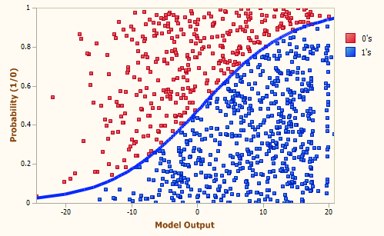
Fig(1)
Support Vector Machine(SVM):

SVM was initially developed in 1960’s then got some improvement till 1990’s, and now at present state it is one of the most powerful weapons among the different classification algorithms. It is one of the best classification methods with an extensive range of applications including credit scoring. The credit scoring models are created to bifurcate clients as either defaulter or non-defaulter on the basis of client characteristics such as age, income, and marital condition considered as attributes. Discussing the problem, we try to apply a grid search algorithm using K-fold cross-validation to determine the most related parameter values of different kernel function of SVM. Further for evaluation of the prediction accuracy of SVM, we compare its performance with those of linear discriminant analysis(LDA), logistic regression analysis(Logit) K-nearest neighbors (K-NN), classification and regression tree and neural networks(ANN). The entire prediction experiment depicts, SVM gives quite a good accuracy. While applying SVM we need to get acquainted with basic concept of model parameters. First step while implementing SVM is to set the model’s parameter. In this research we have used RBF kernel, which contains two parameters which needs to be determined according to the dataset we are using. The two important kernel parameter which RBF kernel uses are C and gamma(γ). By applying grid search method, we can find out the best values of C and gamma, for the kernel RBF.

(4)
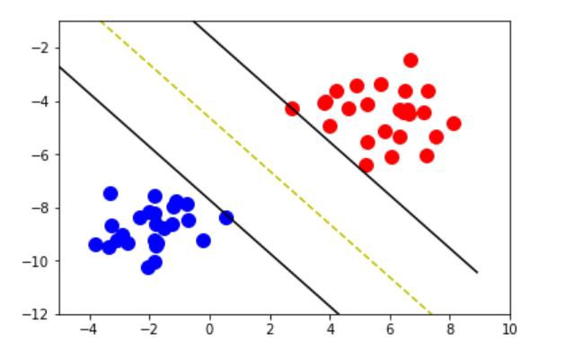
Fig 2

Random Forest:

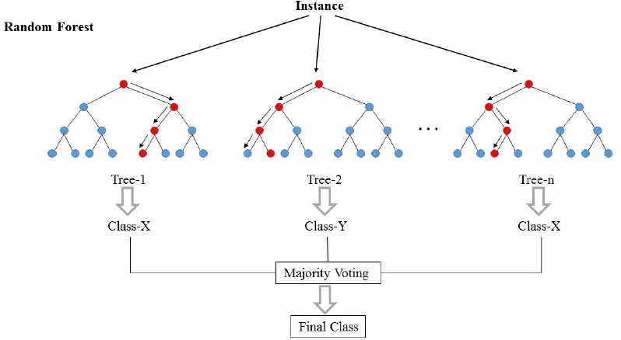
Fig3
Random forests or random decision forests are an ensemble learning method for classification, regression and other tasks, that operate by constructing a multitude of decision trees at training time and outputting the class that is the mode of the classes (classification) or mean prediction (regression) of the individual trees. Random decision forests correct for decision trees’ habit of over fitting to their training set.
(5)

Neural Network:

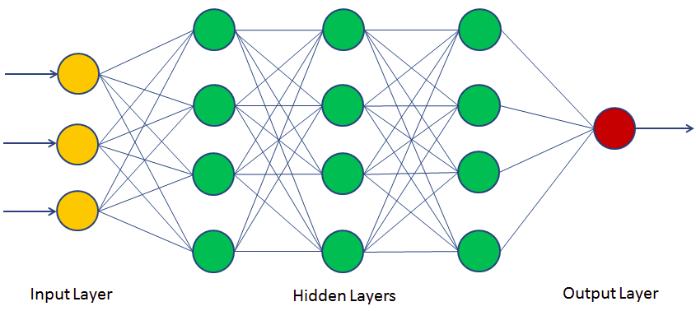

Fig 4

A neural network consists of units (neurons), arranged in layers, which convert an input vector into some output. Each unit takes an input, applies a (often nonlinear) function to it and then passes the output on to the next layer. Generally, the networks are defined to be feed-forward: a unit feeds its output to all the units on the next layer, but there is no feedback to the previous layer. Weightings are applied to the signals passing from one unit to another, and it is these weightings which are tuned in the training phase to adapt a neural network to the particular problem at hand.

Nearest Neighbor:

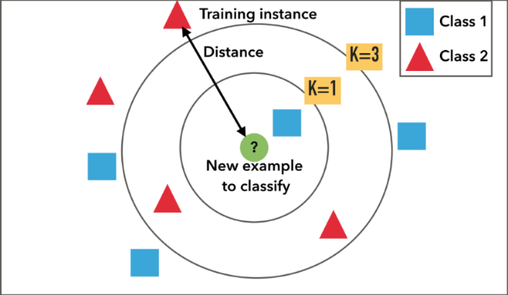

Fig5

(6)
The k-nearest-neighbor’s algorithm is a classification algorithm, and it is supervised: it takes a bunch of labelled points and uses them to learn how to label other points. To label a new point, it looks at the labelled points closest to that new point (those are its nearest neighbors), and has those neighbors vote, so whichever label the most of the neighbors have is the label for the new point (the “k” is the number of neighbors it checks).

K-Fold Cross Validation:
In K Fold cross validation, the data is divided into k subsets. Now the holdout method is repeated k times, such that each time, one of the k subsets is used as the test set/ validation set and the other k-1 subsets are put together to form a training set. The error estimation is averaged over all k trials to get total effectiveness of our model. As can be seen, every data point gets to be in a validation set exactly once, and gets to be in a training set k-1 times. This significantly reduces bias as we are using most of the data for fitting, and also significantly reduces variance as most of the data is also being used in validation set. Interchanging the training and test sets also adds to the effectiveness of this method. As a general rule and empirical evidence, K = 5 or 10 is generally preferred, but nothing’s fixed and it can take any value.

2.2 TECHNOLOGIE USED:

Spyder Software- We used this software because of its features which are as follows.

- Editor: Work efficiently in a multi-language editor with a function/class browser, code analysis tools, automatic code completion, horizontal/vertical splitting, and go-to-definition.
- IPython Console: Harness the power of as many IPython consoles as you like within the flexibility of a full GUI interface; run your code by line, cell, or file; and render plots right inline.
- Variable Explorer: Interact with and modify variables on the fly: plot a histogram or timeseries, edit a dateframe or Numpy array, sort a collection, dig into nested objects, and more.
- Profiler: Find and eliminate bottlenecks to unchain your code's performance
- Debugger: Trace each step of your code's execution interactively.
- Help: Instantly view any object's docs, and render your own.

2.3 LIBRARIES USED:

Pandas for data extraction and preparation:

Pandas is a very popular library that provides high-level data structures which are simple to use as well as intuitive. It has many inbuilt methods for grouping, combining data and filtering as well as performing time series analysis. Pandas can easily fetch data from different sources like SQL databases, CSV, Excel, JSON files and manipulate the data to perform operations on it.
(7)

Matplotlib for data visualization:
It is a standard Python library used by every data scientist for creating 2D plots and graphs. It’s pretty low-level, meaning it requires more commands to generate nice-looking graphs and figures than with some advanced libraries. However, the flip side of that is flexibility. With enough commands, you can make just about any kind of graph you want with Matplotlib. You can build diverse charts, from histograms and scatterplots to non-Cartesian coordinates graphs.

Scikit-learn for working with classical ML algorithms:
Scikit-learn is one the most popular ML libraries. It supports many supervised and unsupervised learning algorithms. Examples include linear and logistic regressions, decision trees, clustering, k-means and so on.
It builds on two basic libraries of Python, NumPy and SciPy. It adds a set of algorithms for common machine learning and data mining tasks, including clustering, regression and classification. Even tasks like transforming data, feature selection and ensemble methods can be implemented in a few lines. For a novice in ML, Scikit-learn is a more-than-sufficient tool to work with, until you start implementing more complex algorithms.
- Tensorflow for Deep Learning:
If you are in the world of machine learning, you have probably heard about, tried or implemented some form of deep learning algorithm. Are they necessary? Not all the time. Are they cool when done right? Yes!The interesting thing about Tensorflow is that when you write a program in Python, you can compile and run on either your CPU or GPU. So you don’t have to write at the C++ or CUDA level to run on GPUs. It uses a system of multi-layered nodes that allows you to quickly set up, train, and deploy artificial neural networks with large datasets.
- NumPy:
It is a module for Python. The name is an acronym for "Numeric Python" or "Numerical Python". It is pronounced (NUM-py) or less often (NUM-pee)). It is an extension module for Python, mostly written in C. This makes sure that the precompiled mathematical and numerical functions and functionalities of Numpy guarantee great execution speed.
(8)

METHODLOGY

  - Detailed methodology that will be adopted:

1). Data pre-processing:
1.1) Uploading the dataset
1.2) Conversion of categorical attribute into numeric values.

2). Data modelling:
2.1). splitting dataset into test and train models,
2.2). Attribute reduction, using LDA and PCA
2.3). Feature Scaling

3). Applying classification algorithm
4). Tuning model using Grid Search, K4-Cross validation.
5). Accuracy of different classifiers

  - The Block Diagram of the METHODOLOGY:

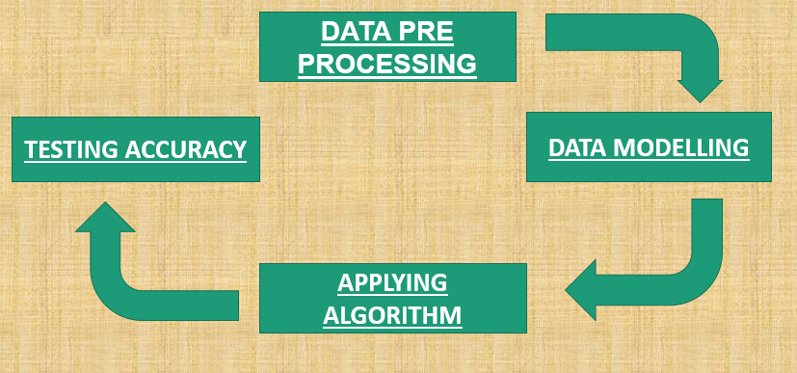

Fig 6

(9)
IMPLEMENTATION AND RESULTS

The results we obtained by applying different classification models are in the form of
Confusion Matrix and the Accuracy Precision and Recall we abating from that confusion matrix:

- Logistic Regression:

Confusion matrix obtained:

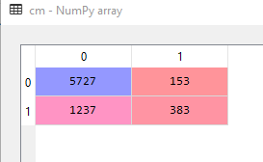

ACCURACY | PRECISION | RECALL
81.46% | 82.2% | 97.37%

- Support Vector Machine(SVM):

Confusion matrix obtained:
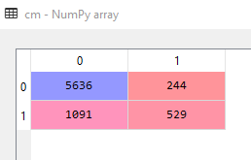
(10)

ACCURACY | PRECISON | RECALL
82.2% | 83.7% | 91.42%

- Random Forest:

Confusion matrix obtained:

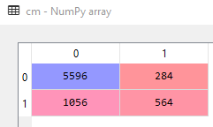

ACCURACY | PRECISON | RECALL
82.1% | 84.12% | 95.17%

- Neural Network:

Confusion matrix obtained:

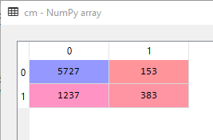
(11)

ACCURACY | PRECISON | RECALL
82.28% | 83.93% | 95.7%

- K-NN:

Confusion matrix obtained:

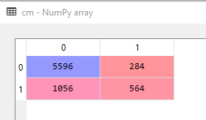

ACCURACY | PRECISON | RECALL
79.62% | 83.55% | 92.4%

6). K- fold cross validation:

ACCURACY | STANDARD DEVIATION
81.96% | 0.48%

(12)

CONCLUSION

5.1 PROGRESS CHART:

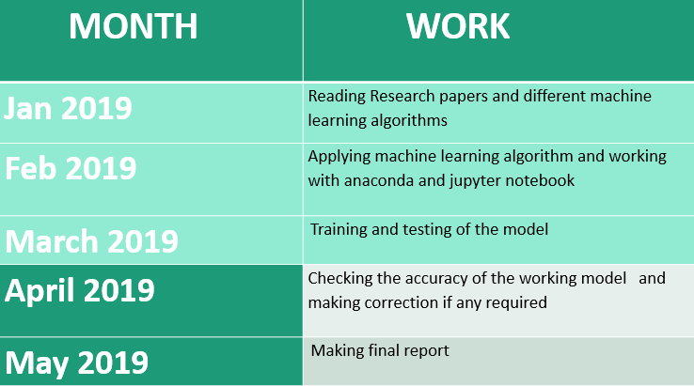

5.2 ACCURAY CHART:

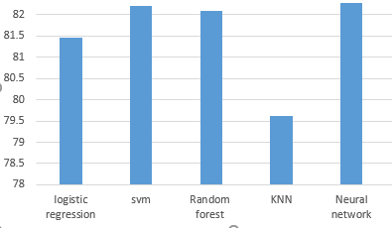
(13)

- We conclude that almost all the algorithms are giving acuuracy around 80%.
- The best accuracy we obtained is by using Neural Network.
- So we can use Deep Learning to predict the Credit Scoring it will give us the best result.

(14)
REFERENCES

- Proceedings of the 2011 International Conference on Industrial Engineering and Operations Management Kuala Lumpur, Malaysia, January 22 – 24, 2011

- (IJACSA) International Journal of Advanced Computer Science and Applications, Vol. 8, No.7, 2017

- West, D., Dellana, S., & Qian, J. (2005). Neural network ensemble strategies for financial decision applications. Computers & operations research, 32(10), 2543-2559.

- Yeh, I. C., & Lien, C. H. (2009). The comparisons of data mining techniques for the predictive accuracy of probability of default of credit card clients. Expert Systems with Applications, 36(2), 2473-2480.

- Rokach, Lior, and Oded Maimon. Data mining with decision trees: theory and applications. World scientific, 2014, pp. 168.

- Witzany, Jiří. Credit risk management and modeling. Praha: Oeconomica, 2010, pp. 46.

- Loh, Wei‐Yin. ―Classification and regression tree methods.‖ Encyclopedia of statistics in quality and reliability (2008), pp. 315-323

- Huang, S. C., & Day, M. Y. (2013, August). A comparative study of data mining techniques for credit scoring in banking. In Information Reuse and Integration (IRI), 2013 IEEE 14th International Conference on (pp. 684-691). IEEE.

(15)

